

E-Track Application

Makson Healthcare Pvt. Ltd.

The document details the summary of solution architecture and approach for the development of E-Track for Makson Healthcare Pvt. Ltd(MHPL). The document is based on the inputs, system study, discussions and meeting held between BCI & Makson Healthcare Pvt. Ltd (MHPL) Pvt Ltd (MHPL). This track & trace system should be implemented as per Makson (MHPL), P&G and DGFT guidelines as per requirements.

PO NO

MHPL|HYD|CAP|23-24|016

MHPL|HYD|CAP|23-24|017

Software Requirement Specification (SRS)

BAR CODE INDIA, 145 Udyog Vihar Phase 1, Gurugram, Haryana-122016, PH: 0124 4337555

**Submission Date: 1-Sept-2023**

**Version: 1.2.0**

**Prepared By: Leena**

|  |  |  |  |  |
| --- | --- | --- | --- | --- |
| REVISION NO. | DATE | PREPARED BY | REVIEWED BY | COMMENT |
| 1.0.0 | 09-08-2023 | Prateeksha, Leena | Chandrakant Shindkar | Software Requirement Specification document for Makson Healthcare Pvt. Ltd. for DGFT eTrack Application. |
| 1.1.0 | 23-08-2023 | Leena | Santosh Parekh | Annexure of line barcode details is added. |
| 1.2.0 | 01-09-2023 | Leena | Chandrakant Shindkar, Santosh Parekh | Incorporated changes as per Makson Healthcare Pvt. Ltd. team comments |

REVISION HISTORY

**Abbreviations:**

**Client:** Makson Healthcare Pvt. Ltd., henceforth will be referred as Makson Healthcare Pvt Ltd (MHPL).

**Vendor:** Bar Code India, henceforth, will be referred as BCI.

Notice:

This document contains information, which is the proprietary property of Bar Code India. This document is received in confidence and its contents cannot be disclosed or copied without the prior written consent of Bar Code India.

Nothing in this document constitutes a guaranty, warranty, or license, express or implied. Bar Code India disclaims all liability for all such guaranties, warranties, and licenses, including but not limited to: Fitness for a particular purpose; merchantability; not infringement of intellectual property or other rights of any third party or of Bar Code India; indemnity; and all others. The reader is advised that third parties can have intellectual property rights that can be relevant to this document and the technologies discussed herein and are advised to seek the advice of competent legal counsel, without obligation of Bar Code India.

The changes should be mutually agreed and cancellation rights should have both the ends. Bar Code India makes no warranty for the use of this document and assumes no responsibility for any errors that can appear in the document nor does it make a commitment to update the information contained herein.

COPYRIGHT

Copyright © ***BCI*** 2023. All rights reserved.

TRADEMARKS

*Other product and corporate names may be trademarks of other companies and are used only for explanation and to the owners' benefit, without intent to infringe.

Table of Contents

1 Specification Organization 1

2 Introduction 2

2.1 Intended Audience and Reading Suggestions 2

2.2 Project Scope 3

3 User Interface Specification Conventions 4

4 System Log 5

4.1 Error Logs 5

5 Application Modules- Web, Desktop & Device 6

5.1 Application Login 6

5.2 Menu 8

5.3 User Management & Master Data 9

5.3.1 User Master 9

5.3.2 Reset Password 11

5.3.3 Change Password 11

5.3.4 Company Master 11

5.3.5 Plant Master 12

5.3.6 GTIN Master 14

5.3.7 Line Master 15

5.3.8 Consignee Master 16

5.3.9 Printer Master 18

5.3.10 Label Design Master 19

6 Transactions 21

6.1 Batch Creation 21

6.1.1 Serial Number Generation 22

6.1.2 Label Printing 23

6.1.3 Job Creation 24

6.1.4 Scanning 26

6.1.5 Rejection 27

7 Reports 29

8 Annexure 30

9 SRS Scope Change Process 37

9.1 Before Sign Off 37

9.2 After Sign Off 37

9.3 SRS Acceptance 37

# Specification Organization

The objective of this document is to supply underlying concepts, procedures, and formats used in the design, development and installation of this software application. This specification consists of three sections organized as follows:

**Section 1: Introduction**

This section provides hardware requirements and documentation conventions.

**Section 2: User Interface**

This section depicts screen design and logic flow, and is categorized into two groups:

* Application Function Module
* Common Routine

**Section 3: System Architecture**

This section provides information of system architecture.

Specifications:

Hardware Requirements

The following are the minimum hardware requirements for your Track & Trace System. In a testing as well as production environment, the volume of traffic may dictate greater hardware requirements for your servers.

|  |  |
| --- | --- |
| Component | Minimum Requirement |
| Processor | Minimum: Intel Xeon Processor 3.1 GHz Recommended: Intel Xeon Processor 3.1 GHz or faster |
| Memory | Minimum: 16 GB RAM  Recommended: 16 GB RAM or Later |
| Available Disk Space | Minimum: 100 GB  Recommended: 500 GB or Greater |
| DB Backup | Minimum: daily database backup by customer IT team.  Recommended: daily or weekly database backup by customer IT team. |

# Introduction

## Intended Audience and Reading Suggestions

The scope of this document is to provide the understanding of this solution to user & development teams associated with the application development & implementation.

This document major emphasizes on providing clear understanding of e-Track Application.

This solution comprises of:

* Device Application
* Desktop Application
* ERP Integration (API Interface)

Hardware:

* CIJ Printer
* P&A Machine
* Barcode Scanner
* Barcode Printer

## Project Scope

The e-Track application implements the persistent data requirement for management of packaging Serialization System in compliance with 21 CFR Part 11 requirements and Serialization guidelines of DGFT India.

This would require development of **Wi-Fi enabled application for real time transaction** i.e.the data will be captured in real-time, once the data has been collected, the database can then provide useful reports about status of material production area.

# User Interface Specification Conventions

This section specifies the user interface portion of the application.

**Section Organization**

The User Interface Specification presents screen displays or “**Dialogs**”.

**Documentation Conventions**

This section incorporates illustrations of the application user interface. Each screen display “Dialog” consists of the screen display image, a process name, a paragraph documenting the processing required for the dialog, a paragraph listing the navigation options, and a table listing for each variable field on the dialog, its database source or destination, format, and any instructions required to process the field.

The following section contains a sample dialog with each area identified.

# System Log

System shall maintain internal logs for application.

## Error Logs

These logs will contain any errors encountered during runtime for faster resolution of any problem post deployment.

# Application Modules- Web, Desktop & Device

## Application Login

This login module will provide access to the application modules. Here the admin/user needs to enter the login detail to enter in the application and to perform the desired actions.



**Process:** User needs to enter the User Name/ID and Password in display fields and press the Login button. Application will validate the user credential.

*User will be able to view only those screens/ modules of which he has been given access rights to.*

**Validation**

* User Name/ ID will be unique for all users.
* User Name/ ID and Password length will be set.
* After 3 unsuccessful login user has to reset the password.

*To check the steps refer 5.3.2 section.*

After successful login application menu screen will appear. Menu screen will have the Master, Label Printing, DB Settings and Reports options etc.

**Login Sample Screen:**

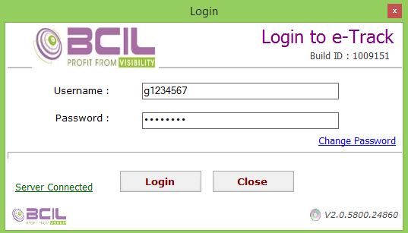

## D:\My files\BCI\Makson\Makson srs\docs by prateeksha\menu.jpgMenu

The menu consist of:

* Batch Creation
* Generation
* Printing
* Job Creation
* Scanning
* Rejection
* Reports

## User Management & Master Data

The module will let application administrator to manage the Users, and the rights assigned to the same; the rights will define authorized application access of users.

### User Master

The module will be used to add, save, delete a particular user details. Admin user will enter details of application’s user. The users will be provided with unique id and password through which they will be able to login to the system. Using this module, admin will provide the access rights of the required application modules to user.

|  |  |
| --- | --- |
| **Data Fields** | 1. Plant Code 2. Department Name 3. User Id 4. User Name 5. Employee Code 6. Email Id 7. User Status 8. Remark 9. Rights |
| **Process Steps** | 1. Select Plant Code from dropdown. 2. Select Department Name from dropdown. 3. Enter User Id, Username, Employee Code, Email Id and Remark.   *\*User Name and Password should be equal to or greater than eight characters.*   1. Select User Type from dropdown. 2. Select Modules for which Access rights needs to be assigned to user.   *\*By default admin get rights of all modules and for users, admin can decide for which modules/rights should be accessible to particular users.*   1. Save and Update the details in database. 2. User can export the details in Excel format, if required. |
| **Functions** | Add, Edit/Update, Deactivate and Export to Excel as per Makson Healthcare Pvt. Ltd. requirement. |

**Sample Screen:**

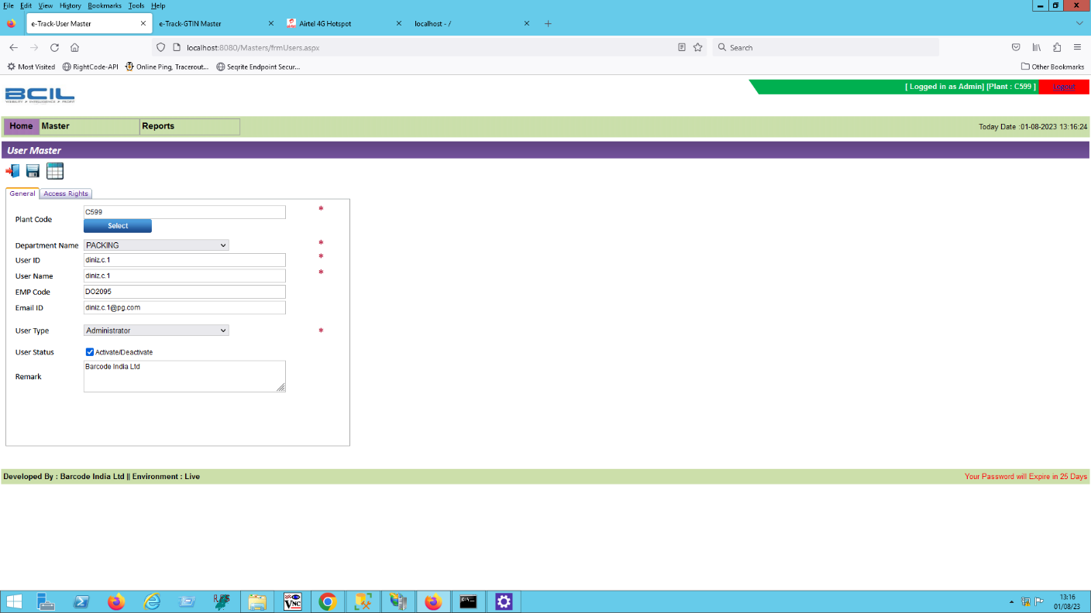

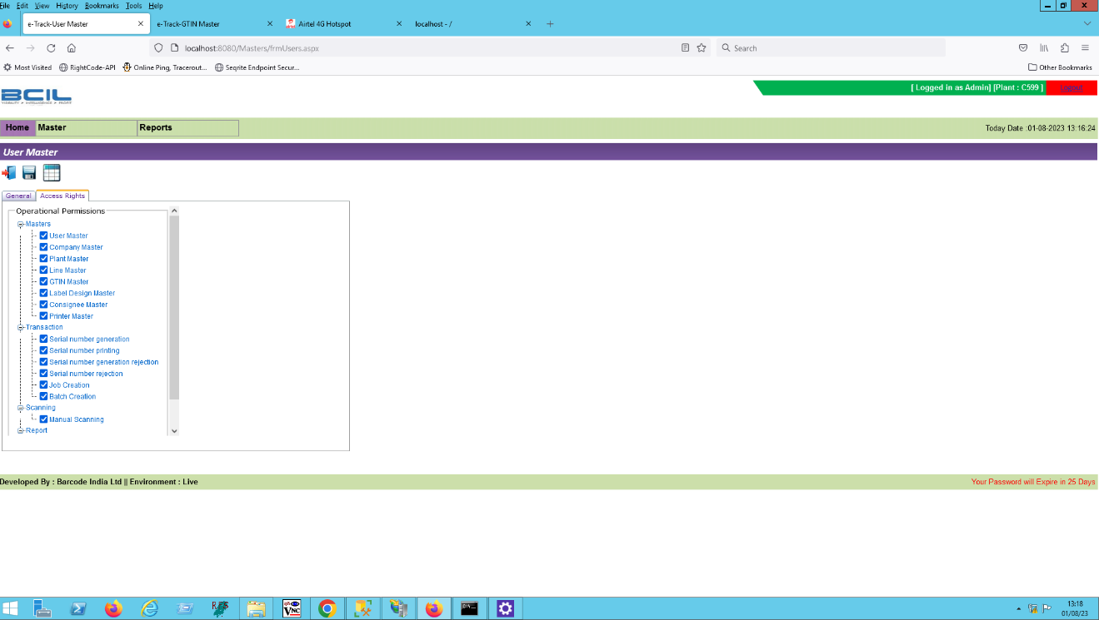

### Reset Password

|  |  |
| --- | --- |
| **Process Steps** | 1. User enter the invalid login credentials for 3 times. 2. User is deactivated. 3. User inform the admin for activation. 4. Admin login on application with his credentials. 5. Admin click on grid and select the deactivated user. 6. Admin activate the user. 7. Enter the User credentials set by admin. 8. Reset password screen will be displayed. 9. User will enter the new and confirm password. |

### Change Password

|  |  |
| --- | --- |
| **Process Steps** | 1. User will click on change password. 2. Enter old password and new password in respective fields. 3. Click on confirm password button. 4. The password will be changed. 5. Click on login. 6. Enter new password for login. |

### Company Master

The master module will be used to save the Company details against in database.

|  |  |
| --- | --- |
| **Data Fields** | 1. GS1 Prefix (*BCI will create 4 instances of company prefix as confirmed by Makson Healthcare Pvt. Ltd*) 2. Company Name 3. Company Address 1 4. Company Address 2 5. City 6. State 7. Country 8. Pincode 9. Status i.e. Active/ Inactive |
| **Process Steps** | 1. Enter GS1 Prefix, Company Name, City, State and other details. 2. Select Active/ Inactive Status. 3. Save details. 4. Newly added Company details will appear on screen in data grid. 5. User can export the details in Excel format, if required. |
| **Functions** | Add, Edit/Update, Deactivate and Export to Excel as per Makson Healthcare Pvt. Ltd requirement. |

**Sample Screen:**

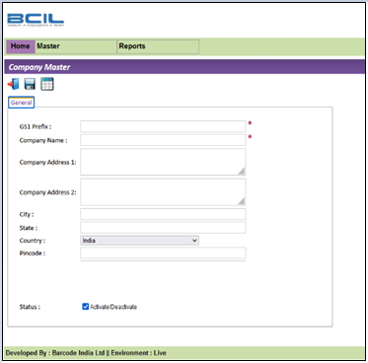

### Plant Master

The master module will be used to save the Plant details against in database.

|  |  |
| --- | --- |
| **Data Fields** | 1. Company (GS1 Prefix) *(Dropdown for selection)* 2. Plant Code 3. Plant Name 4. Plant Address 1 5. Plant Address 2 6. City 7. State 8. Country 9. Pincode 10. Plant Type 11. Remarks 12. Status i.e. Active/ Inactive |
| **Process Steps** | 1. Select Company (GS1 Prefix) from dropdown. 2. Enter Plant Code, Plant Name, Plant Address 1, Plant Address 2, City, State and other details. 3. Save the details. 4. Newly added Plant details will appear on screen in data grid. 5. User can export the details in Excel format, if required. |
| **Functions** | Add, Edit/Update, Deactivate and Export to Excel as per Makson Healthcare Pvt. Ltd requirement. |

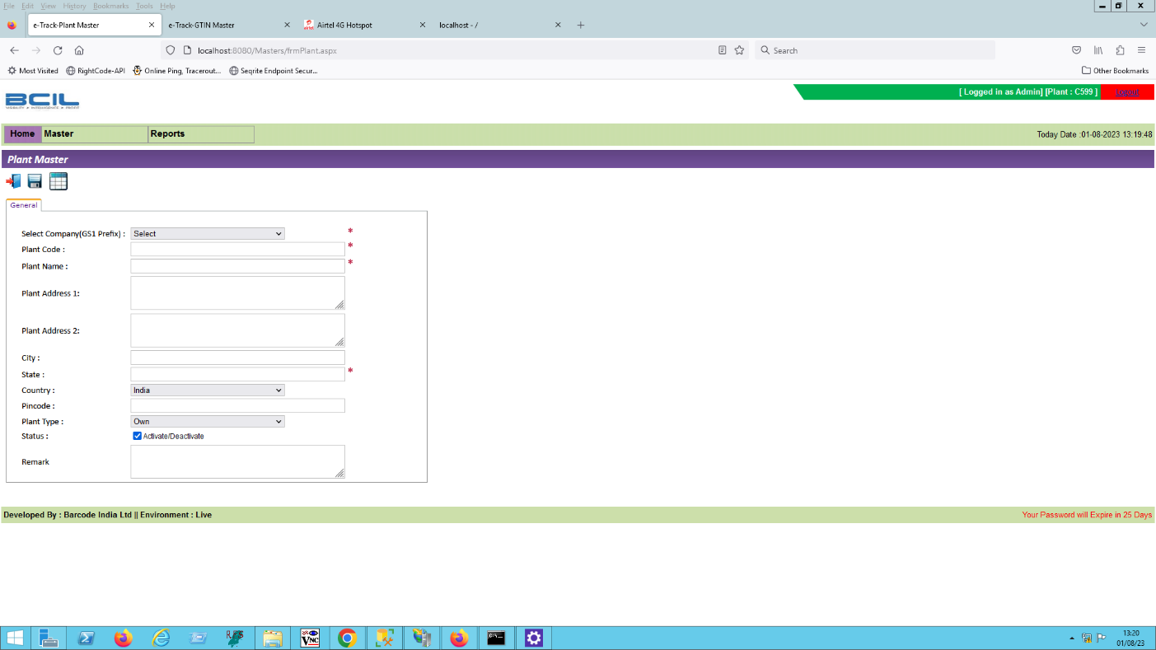**Sample Screen:**

### GTIN Master

This master will be used to view the GTIN details in database. Using this module, user will be able to add, update and delete as per requirement.

|  |  |
| --- | --- |
| **Data Fields** | 1. Company Prefix 2. Packing Level 3. GTIN Code 4. Generate GTIN Code 5. ERP Item Code 6. Product Description 7. Quantity in Box 8. Pack Size 9. Label Design ID 10. Customer ID 11. Expiry Period 12. Status 13. Generic Name 14. Composition 15. Schedule 16. Usage 17. Art Work 18. Remark |
| **Process Steps** | 1. Click on Add button. 2. Select Company Prefix, Packing Level, Label Design ID, Customer ID. 3. Enter GTIN Code, Generate GTIN Code, ERP Item Code, Product Description, Quantity in Box, Pack Size, and other details. 4. Click on Status button to activate it. 5. Select Art Work file by clicking on Browse button.   *\*Fields marked with * are mandatory.*   1. Click on Save. 2. Newly added GTIN details will appear on screen in data grid. 3. User can export the details in Excel format, if required. |
| **Functions** | Add, Edit/Update, Deactivate and Export to Excel as per Makson Healthcare Pvt. Ltd requirement. |

**Sample Screen:**

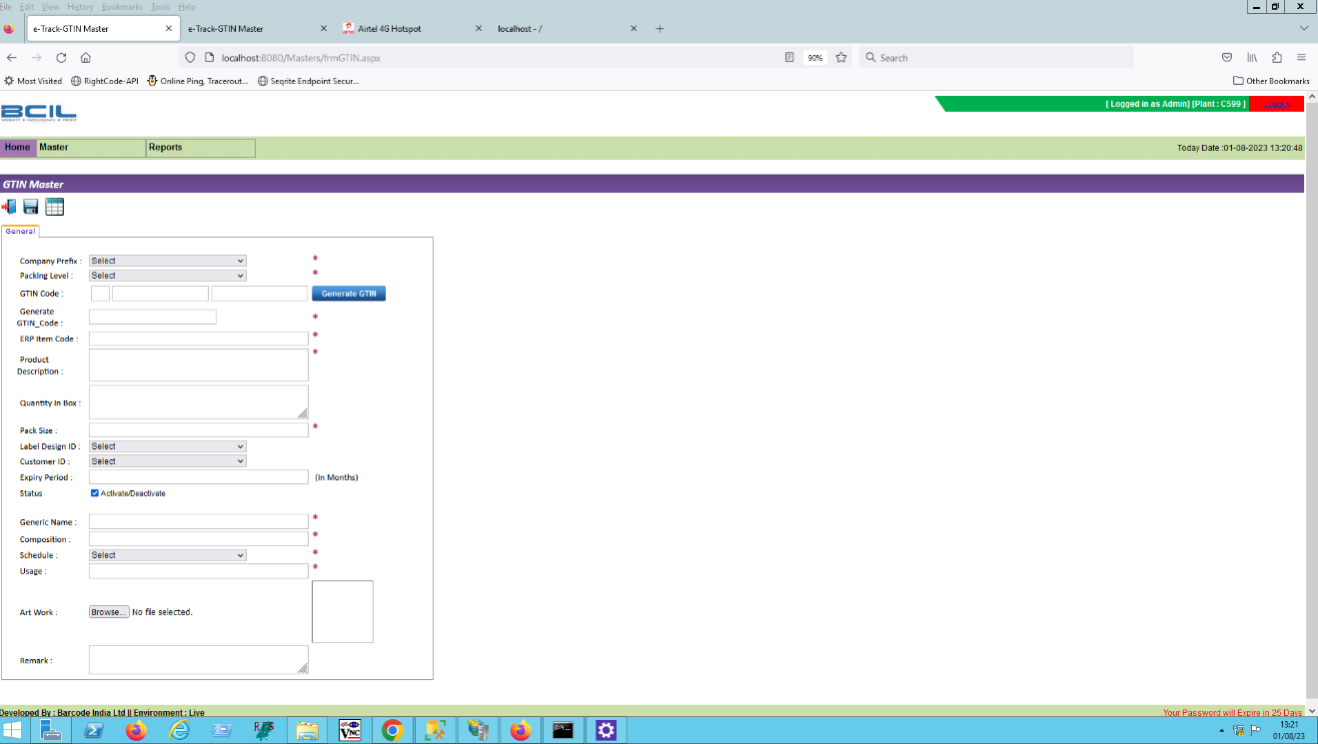

### Line Master

This module will allow user to Line details.

|  |  |
| --- | --- |
| **Data Fields** | 1. Company ID 2. Plant ID 3. Name 4. Status 5. Line Type 6. Product Code 7. Printing Method 8. Label Type 9. Scanning Method 10. Scanning Device 11. Port 12. Device IP 13. Com Port 14. Print File Name 15. Remark |
| **Process Steps** | 1. Click on Add button. 2. Select Company ID, Plant ID, Line Type, Printing Method, Label Type, Scanning Method from dropdown. 3. Enter Name, Product Code, Scanning Device, Port, Device IP, and other details. 4. Click on Status button to activate it. 5. Click on Save. 6. Newly added Line details will appear on screen in data grid. 7. User can export the details in Excel format, if required. |
| **Functions** | Add, Edit/Update, Deactivate and Export to Excel as per Makson Healthcare Pvt. Ltd requirement. |

**Sample Screen:**

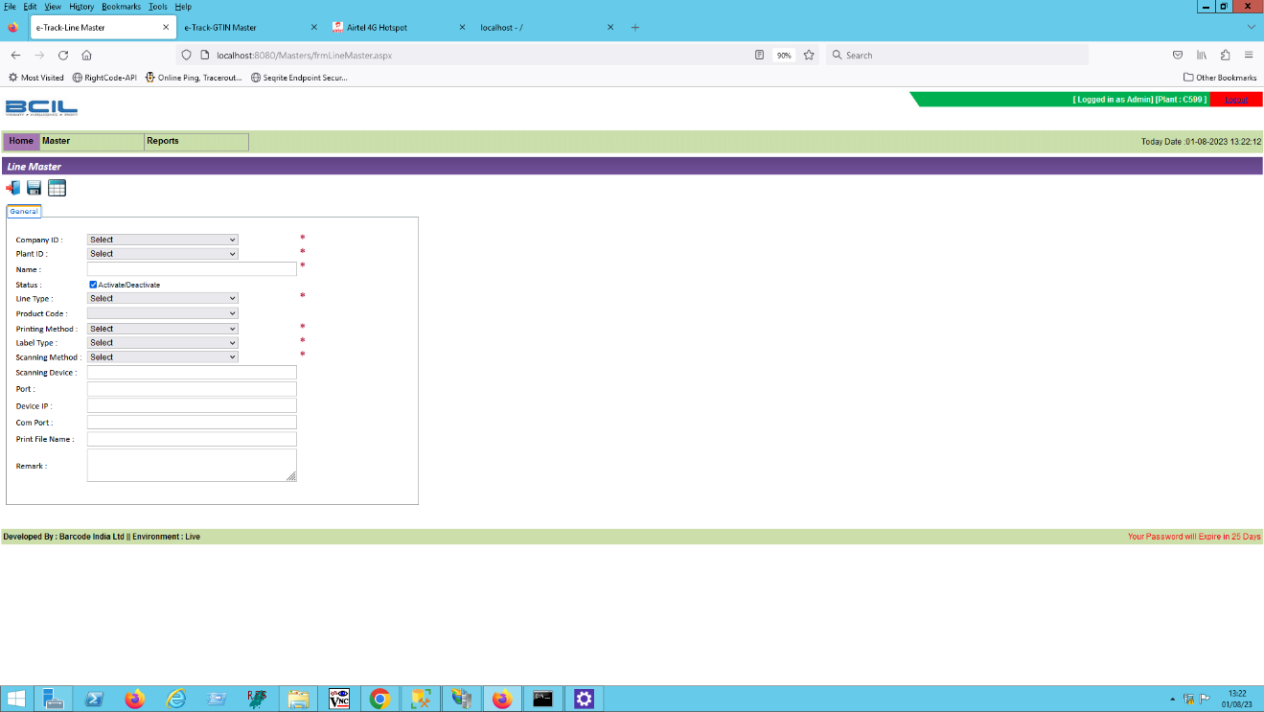

### Consignee Master

This master will be used to view the Consignee details in database. Using this module, user will be able to add, update and delete as per requirement.

|  |  |
| --- | --- |
| **Data Fields** | 1. Customer Name 2. Address 3. Address1 4. Address2 5. City 6. State 7. Pincode 8. Country 9. Tertiary ID 10. Secondary ID 11. Status |
| **Process Steps** | 1. Click on Add button. 2. Enter Customer Name, Address, Address1, Address2, Country. and other details. 3. Select Tertiary ID, Secondary ID from dropdown. 4. Click on Status button to activate it.   *\*Fields marked with * are mandatory.*   1. Click on Save. 2. Newly added Consignee details will appear on screen in data grid. 3. User can export the details in Excel format, if required. |
| **Functions** | Add, Edit/Update, Deactivate and Export to Excel as per Makson Healthcare Pvt. Ltd requirement. |

**Sample Screen:**

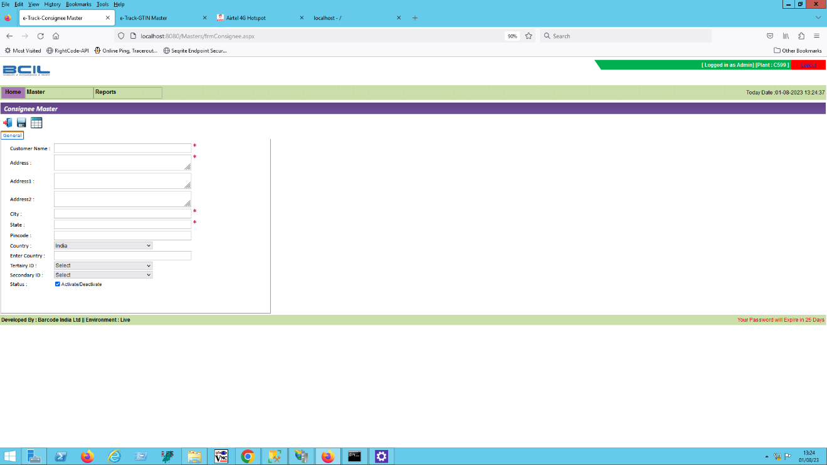

### Printer Master

This master will be used to view the Printer details in database. Using this module, user will be able to add, update and delete as per requirement.

|  |  |
| --- | --- |
| **Data Fields** | 1. Printer Name 2. Printer Type 3. Printer Model 4. Driver Model 5. IP Address 6. Port No 7. Line ID 8. Plant ID 9. Status |
| **Process Steps** | 1. Click on Add button 2. Enter Printer Name, Printer Type, Printer Model, Driver Model. and other details. 3. Select Line ID, Plant ID from dropdown. 4. Click on Status button to Activate it.   *\*Fields marked with * are mandatory.*   1. Click on Save. 2. Newly added Printer details will appear on screen in data grid. 3. User can export the details in Excel format, if required. |
| **Functions** | Add, Edit/Update, Deactivate and Export to Excel as per Makson Healthcare Pvt. Ltd requirement. |

**Sample Screen:**

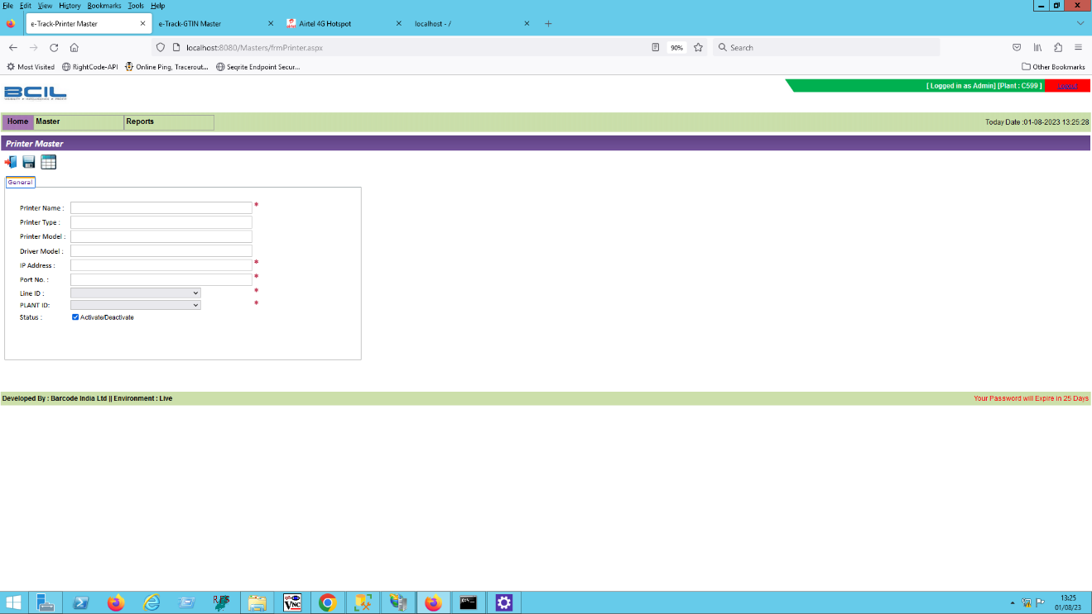

### Label Design Master

This master will save the EAN Code details in database.

|  |  |
| --- | --- |
| **Data Fields** | 1. Packing Level 2. Label Type 3. Label Size 4. PRN Type 5. Plant ID 6. Line ID 7. Select PRN File 8. Status |
| **Process Steps** | 1. Click on Add button. 2. Select Packing Level, Label Type, Label Size, PRN Type, Plant ID, Line ID from dropdown. 3. Enter Label Size. 4. Click on Browse button to select PRN file 5. Click on Status button to Activate it.   *\*Fields marked with * are mandatory.*   1. Click on Save. 2. Newly added Label design details will appear on screen in data grid. 3. User can export the details in Excel format, if required.   *\*The labels design are as per Makson Healthcare Pvt. Ltd data.* |
| **Functions** | Add, Edit/Update, Deactivate as per Makson Healthcare Pvt. Ltd requirement. |

**Sample Screen:**

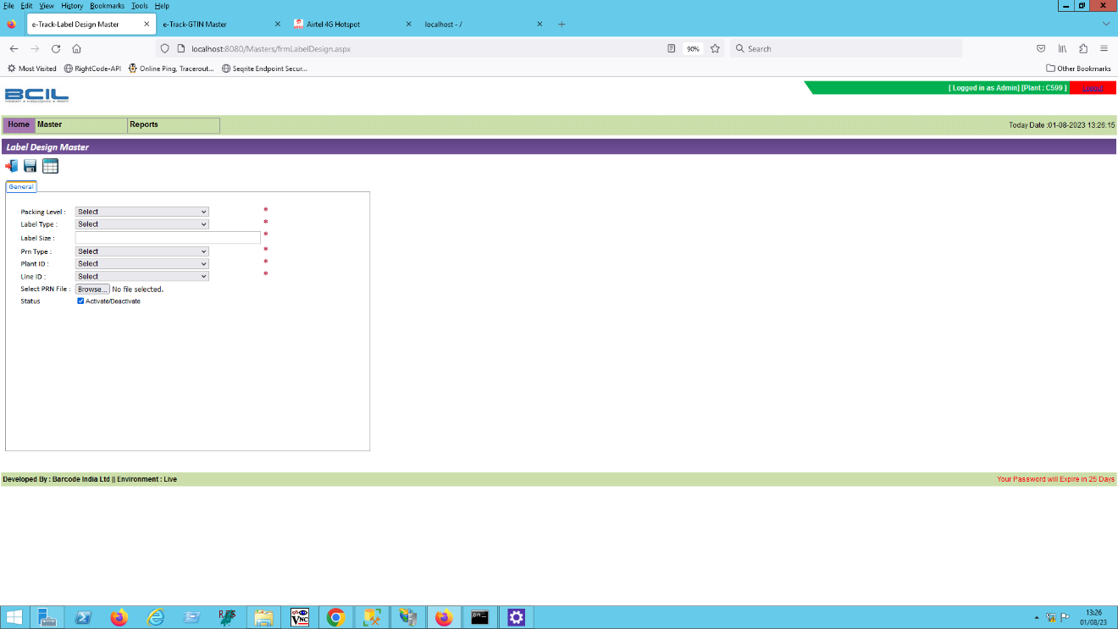

# Transactions

This application will Installed on Desktop Computer on packing line.

## Batch Creation

1. The Batch Creation module is used to create/close batch on desktop computer on packing line.
2. 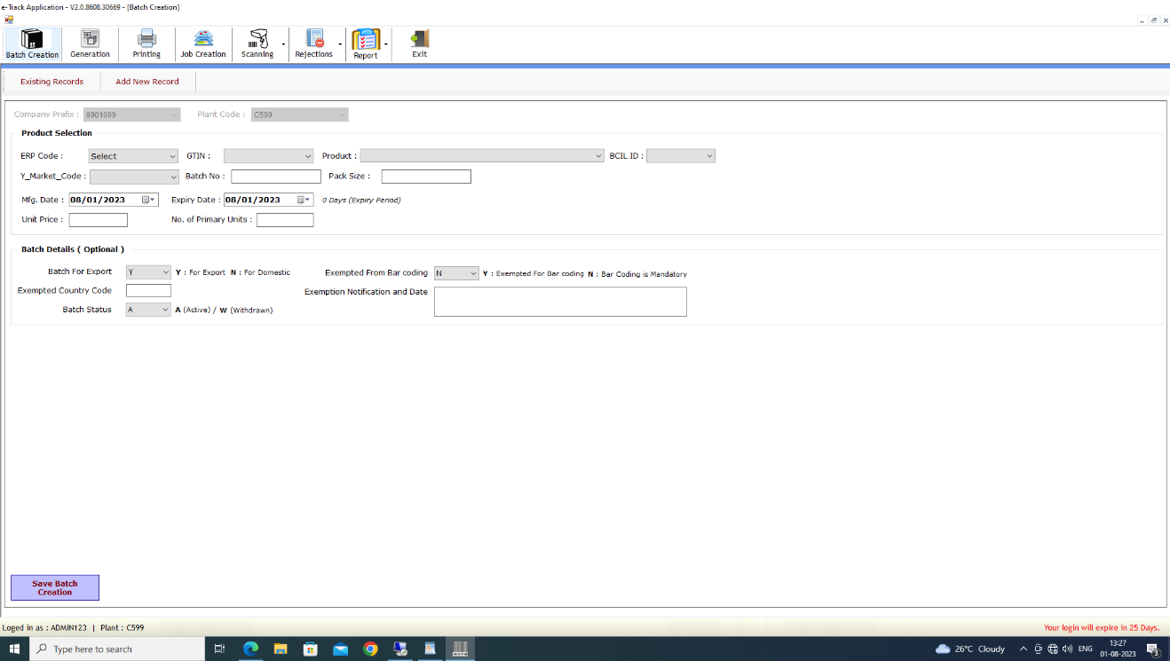To access this module, the User must select on Generation > Batch Creation menu. The Batch Creation screen will be displayed.
3. To Create a New Batch, the User should click on Add New Record.
4. The Plant Code and Company Prefix will be auto-displayed.
5. The User should then select the ERP Code. The corresponding the GTIN, Product, BCIL ID and Pack Size will be displayed.
6. The User will then update the Batch No, Unit price, Number of Primary Units and other batch related details.
7. To save the batch, Click on Save Batch Creation button to save batch.
8. To close an existing batch, the User should select batch from list which they wish to close and click on Close selected Batch(s) button.

### Serial Number Generation

1. Serial No Generation module is used to generate request for a serial no printing. The serial No request generation will be on desktop computer on packing line and the data will be generated on the server.
2. To access this module, the User should select Generation > Serial No Generation menu. The Serial No Generation screen will be displayed.

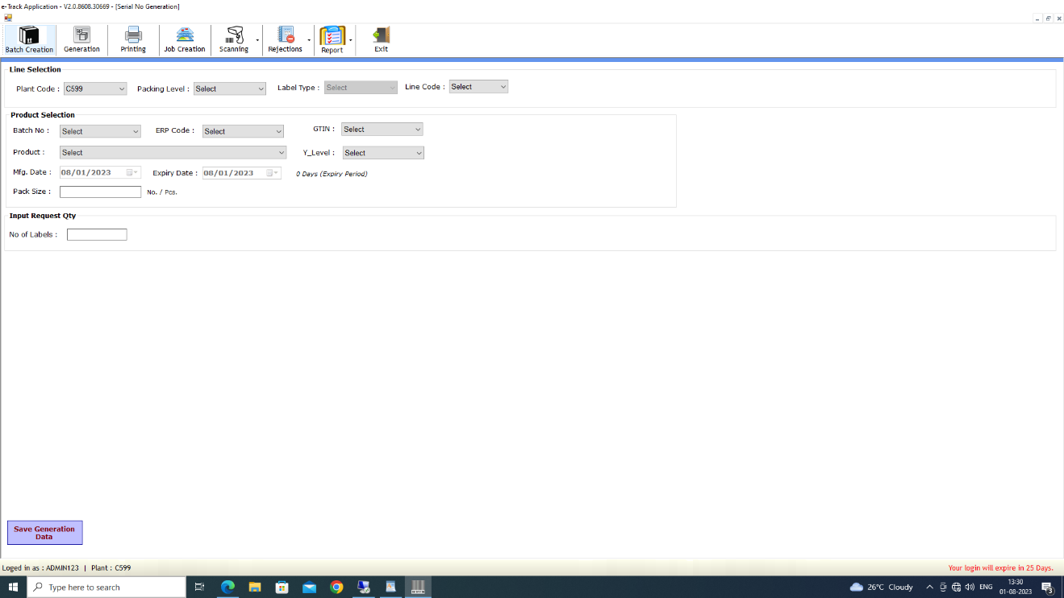

1. To generate request for printing, the User should select Plant Code, Packing Level, Label Type and Line Code in Line Selection.
2. The User should select product, GTIN and product related batch, ERP Code, Y_Level from the list.
3. The User should enter the number of labels in Input Request qty and Pack Size.
4. To save the transaction, click on Save Generation Data Button.

### Label Printing

1. Serial Number printing module is used to print labels.
2. To access this module, The User should click on Printing menu. The Serial Number Printing screen is displayed.

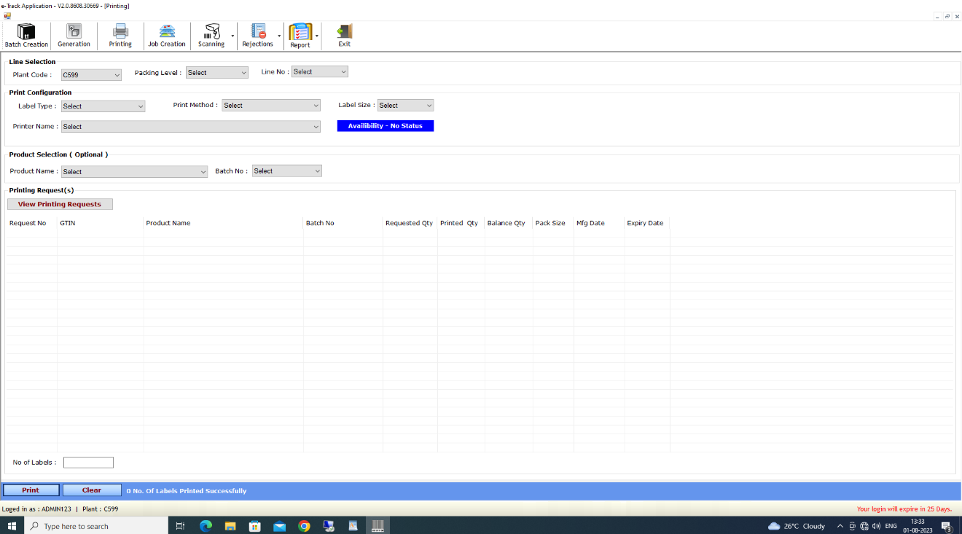

1. To Print Barcode Labels, the User should select Plant Code, Packing Level, and Line No in Line Selection.
2. After selecting Line, Label Type, Print Method and Label Size will get auto displayed for that line.
3. The User should then click on View Printing Requests Button. The generated request will be displayed for selected line.
4. The User should select any one record from list and enter No of labels qty (which they wish to print).
5. To print, click on print Button.

### Job Creation

1. Mapping Job Creation module is used to Create Job against specific GTIN and batch for a packing process.
2. To access this module, User should click on Job Creation menu. The Job Creation screen will be displayed.

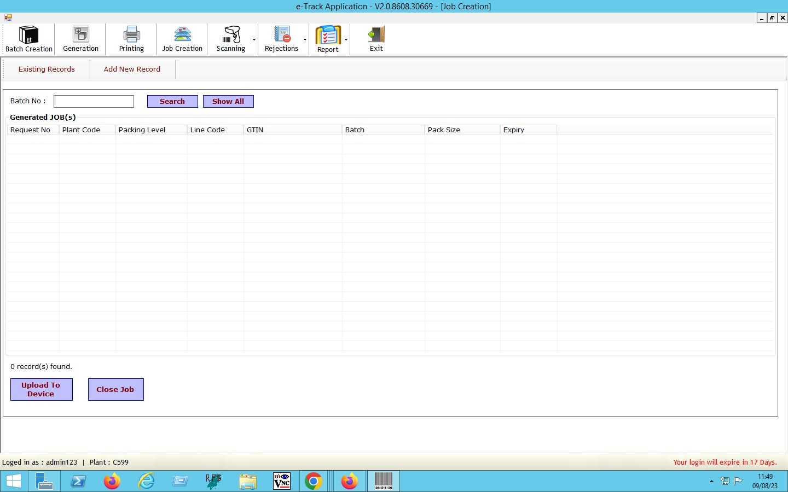

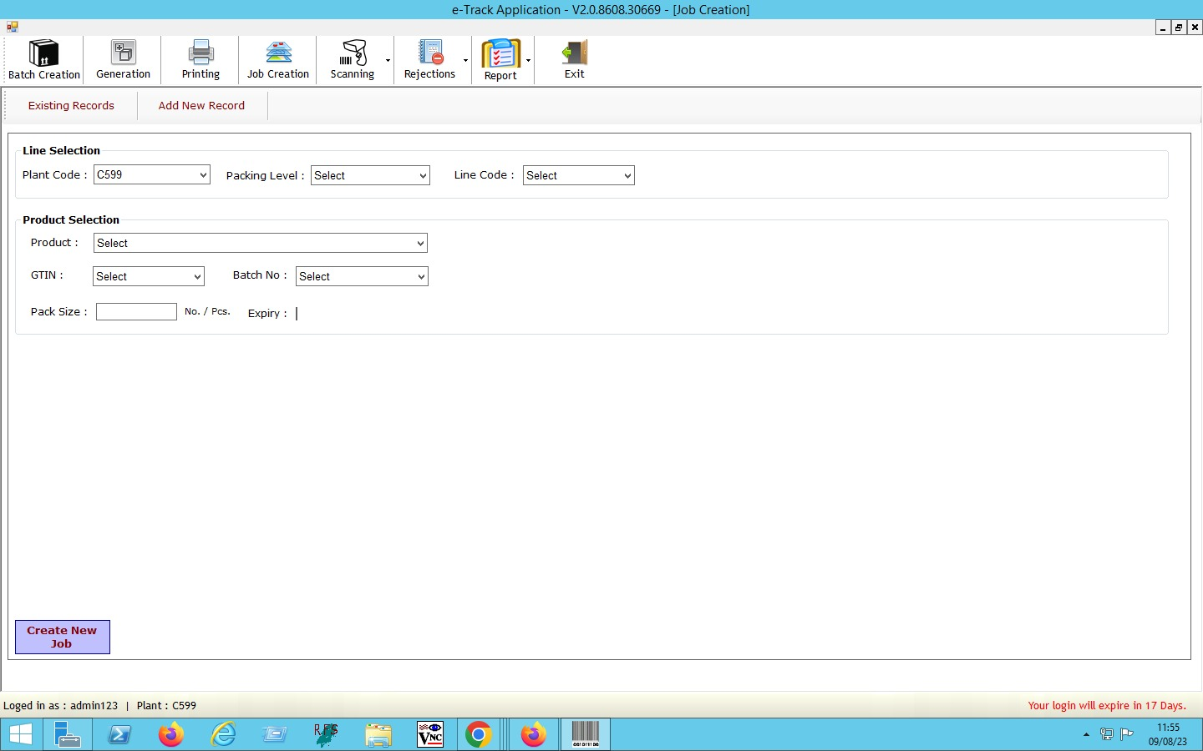

1. To create a new Job, click on Add New Record button.
2. Select Plant Code, Packing Level, Line Code in Line Selection.
3. The User should then select Product, GTIN and Batch No in Product Selection.
4. Enter Pack Size.
5. After selecting Values, the User should click on Create New Job Button and Job will be displayed.

**To Upload to Device (For Offline Scanning)**

1. To perform the uploading process, the User should confirm if the device is connected.
2. The User should then select the Job from list which they wish to upload and click on Upload Button

**To Close Existing Jobs**

1. The User should select Job from list which they wish close and then click on **Close Job** Button

### Scanning

#### Parent Child Scanning (Homogenous)

1. Click on Mapping Scanning. The Mapping Scanning will be displayed.
2. 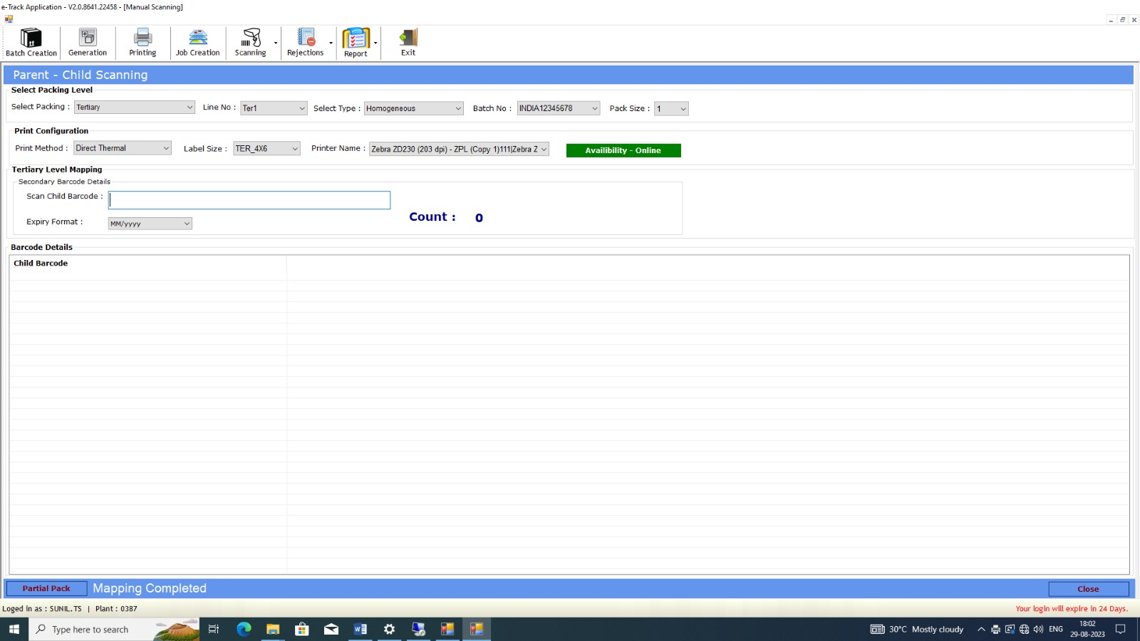If device is connected, then the User should select Packing level as a ’Tertiary ’, Line No from dropdown.
3. By default Homogeneous label type will get selected.
4. Select Batch No, Pack Size drop dropdown.
5. Print Configuration details will be displayed on the screens after selection of Line No.
6. Scan Child Barcode.
7. Child Barcode details will be displayed on the screen.
8. Scan count will be displayed on the screen.
9. When the Pack Size matched to scan count, the tertiary label will be printed.

### Rejection

#### General Request Rejection

1. Generation Request Rejection module is used to Reject Serial No generation request.
2. This module will be accessible on both client and server system.
3. 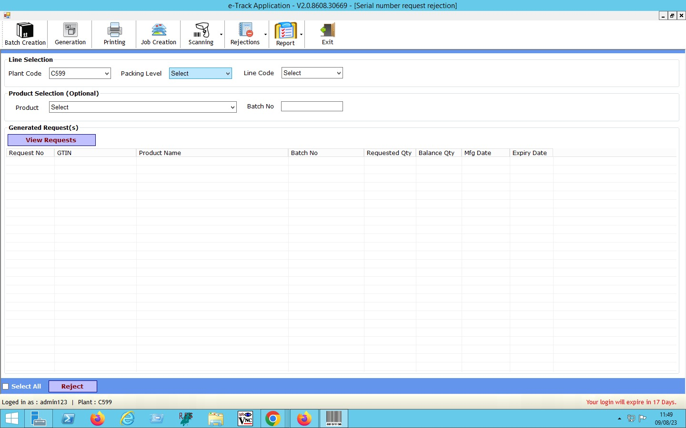To access this module, the User should click Rejection > Generation Request Rejection menu.
4. Select Plant Code, Packing Level, Line code from dropdown for Line Selection.
5. Select Product from dropdown for Product selection section.
6. Enter Batch No.
7. User can view requests in General Request section by clicking on View Requests. button.

#### Serial No Rejection

1. Serial Number Rejection module is used to reject printed barcodes.
2. This module will be accessible on both client and server system.
3. 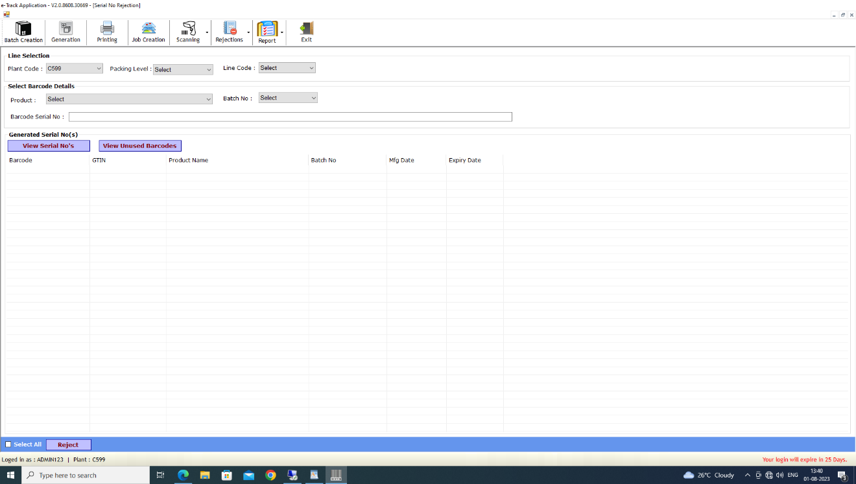To access this module, the User should click Rejection > Serial No Rejection.
4. For Serial No Rejection, the User should select Plant Code, Packing Level, and Line no in Line Selection.
5. The User should then select Product and Batch from Barcode Details.
6. After selecting Values, the User should click on View Serial No’s/View Unused Barcodes Button and generated Barcodes will be displayed.
7. Then select Barcode from list and Click on Reject button.

# Reports

* Tertiary Sumarised Report
* Secondary Summarised Report
* Unutilized Report Secondary
* Unutilized Report Tertiary
* Summary Report
* Wrong Packing Report
* Event Log Report

*\*All data reports can be visible on server as well as client system.*

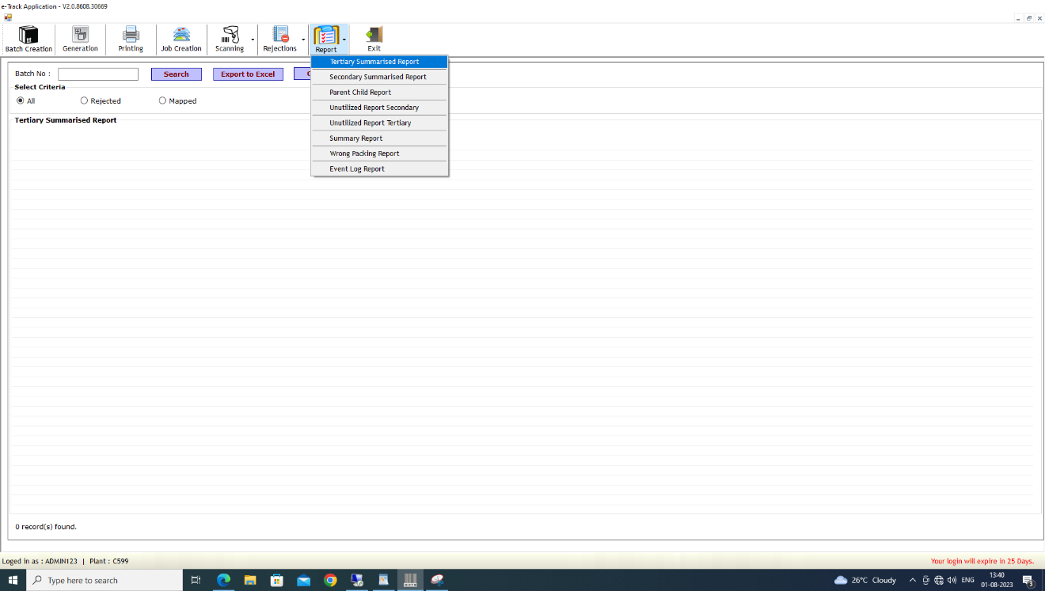

# Annexure

**Line 1 – JAR LINE - PRINT & APPLY**

|  |  |  |  |
| --- | --- | --- | --- |
|  | Example:  P501C2T12#y1 | | |
| **Lines** | **Structure** | **Format** | **Rule** |
| Line 1 | GTIN 14 | (01) XXXXXXXXXXXXXX | (01) = Indicates the data following AI (01) is GTIN-14. XXXXXXXXXXXXXX = denotes GTIN-14 of the secondary  pack. GTIN starts with digit 1. |
| Line 2 | Expiry date Human  readable form  (HRF) | EXP. DATE MM/YYYY | EXP. DATE = Expiry date  MM = 2 digit month of expiration YYYY = 4 digit year of expiration |
|  | Part of QR code only  (will not be part of the HRF) | (17)YYMMDD | (17) = Indicates the data following AI (17) is the expiry date  YY = Last two digit of the year of expiration MM = 2 digit month of expiration  DD = 2 digit date of expiration (should be 00) |
| Line 3 | Batch number HRF | BATCH YDDDPPPP$$XX | BATCH = Batch number  Y = Last digit of manufacturing year DDD = Julian Day code of manufacture PPPP = Plant code  $$ = Batch no.  XX = SKU specific code (Refer to Section IV) |
|  | Part of QR code only  (will not be part of the HRF) | (10)YDDDPPPP$$XX | (10) = Indicates the data following AI (10) is the batch no./ lot no. of the secondary package.  Y = last digit of the manufacturing year DDD = Julian Day code of manufacture PPPP = Plant code  $$ = serial no. for the batch  XX = SKU specific code (Refer to Section IV - Specific code per SKU for Jars) |
| Line 4 | Serial Number | (21) aaaaaaaa | (21) = Indicates the data following AI (21) is the serial  no. of secondary package.  aaaaaaaa = Serial number of the secondary pack. The  number can be alphanumeric with maximum 20 digit long.  The number should not be repeated and must remain  unique for all secondary packs. |

**Line 2 – FLAT LINE – INKJET CODING**

|  |  |  |  |
| --- | --- | --- | --- |
|  | Example: | | |
| Line 1 | GTIN 14 | Line 1: (01)XXXXXXXXXXXXXX | Line 1 :  **(01)** = Indicates the data following AI (01) is GTIN-14. **XXXXXXXXXXXXXX** = denotes GTIN-14 of the secondary pack. GTIN starts with 1. |
| Line 2 | Expiry date  Human readable form (HRF)  Part of QR code only (will not be part of the HRF) | EXP. DATE MM/YYYY  (17)YYMMDD | **EXP. DATE** = denotes expiry date  **MM** = 2 digit month of expiration  **YYYY** = 4 digit year of expiration,  **(17)** = Indicates the data following AI(17) is the expiry date  **YY** = Last two digit of the year of expiration,  **MM** = 2 digit month of expiration  **DD** = 2 digit date of expiration (should be 00) |
| Line 3 | Batch number HRF | BATCH YDDDPPPP$$XX | **BATCH** = Denotes batch number  **Y** = last digit of the Year, **DDD** = Julian Day code of Manufacture  **PPPP** = Plant code,  **$$** = Batch no  **XX** = SKU specific code (refer to table given at the end of PI- specific code per sku for flats) |
|  | Part of QR code only (will not be part of the HRF) | (10)YDDDPPPP$$XX | **(10)** = Indicates the data following AI (10) is the batch no./ lot no. of the secondary package  **Y** = last digit of the Year **DDD** = Julian Day code of Manufacture  **PPPP** = Plant code  **$$** = serial no. for the batch **XX** = SKU specific code (refer to table given at the end of PI- specific code per sku for flats) |
| Line 4 | Serial Number | (21)aaaaaaaa | **(21)** = Indicates the data following AI (21) is the serial no. of secondary package **aaaaaaaa** = Serial number of the secondary pack. The number can be alpha numeric with maximum 20 digit long. The number should not be repeated and remain unique for all secondary packs |
|  |  |  |  |
| Line 5 | Manufacturing date  Human readable form only (HRF) | MFG. DATE MM/YYYY | **MFG. DATE** = denotes manufacturing date **MM** = 2 digit month of manufacturing  **YYYY** = 4 digit year of  manufacturing |

**Line 3 – INHALER-1 – INK JET CODING MACHINE**

|  |  |  |  |
| --- | --- | --- | --- |
|  | Example: | | |
| **Lines** | **Structure** | **Format** | **Rule** |
| Line 1 | GTIN 14 | (01)XXXXXXXXXXXXXX | (01) = Indicates the data following AI (01) is GTIN-14.  XXXXXXXXXXXXXX = denotes GTIN-14 of the secondary pack. GTIN starts with digit 1. |
| Line 2 | Expiry date Human readable form (HRF) | EXP. DATE MM/YYYY | EXP.DATE= represents expiry date MM = 2 digit month of expiration YYYY = 4 digit year of expiration |
|  | Part of QR code only (will not be part of  the HRF) | (17)YYMMDD | (17) = Indicates the data following AI (17) is the expiry date YY = Last two digit of expiry year  MM = 2 digit month of expiration  DD = 2 digit date of expiration (should be 00) |
| Line 3 | Batch number (HRF) | BATCH YDDDPPPP$$XX | BATCH = represents batch no.  Y = last digit of manufacturing year DDD = Julian Day code of manufacture PPPP = Plant code  $$ = serial no. for the batch.  XX = SKU specific code (refer to Section IV - Specific Code per SKU) |
|  | Part of QR code only (will not be part of the HRF) | (10)YDDDPPPP$$XX | (10) = Indicates the data following AI (10) is the batch no./lot no. of the secondary package.  Y = last digit of manufacturing year DDD = Julian Day code of manufacture PPPP = Plant code  $$ = serial no. for the batch  XX = SKU specific code (refer to Section IV - Specific Code per SKU) |
| Line 4 | Serial Number | (21)aaaaaaaa | (21) = Indicates the data following AI (21) is the serial no. of the secondary package.  aaaaaaaa= Serial number of the secondary pack. The number can be alphanumeric with maximum 20 digits. The number should not be repeated and must remain unique for all secondary packs. |

**Line 4 – INHALER-2 – INK JET CODING MACHINE**

|  |  |  |  |
| --- | --- | --- | --- |
|  | Example: | | |
| **Lines** | **Structure** | **Format** | **Rule** |
| Line 1 | GTIN 14 | (01)XXXXXXXXXXXXXX | (01) = Indicates the data following AI (01) is GTIN-14.  XXXXXXXXXXXXXX = denotes GTIN-14 of the secondary pack. GTIN starts with digit 1. |
| Line 2 | Expiry date Human readable form (HRF) | EXP. DATE MM/YYYY | EXP.DATE= represents expiry date MM = 2 digit month of expiration YYYY = 4 digit year of expiration |
|  | Part of QR code only (will not be part of  the HRF) | (17)YYMMDD | (17) = Indicates the data following AI (17) is the expiry date YY = Last two digit of expiry year  MM = 2 digit month of expiration  DD = 2 digit date of expiration (should be 00) |
| Line 3 | Batch number (HRF) | BATCH YDDDPPPP$$XX | BATCH = represents batch no.  Y = last digit of manufacturing year DDD = Julian Day code of manufacture PPPP = Plant code  $$ = serial no. for the batch.  XX = SKU specific code (refer to Section IV - Specific Code per SKU) |
|  | Part of QR code only (will not be part of the HRF) | (10)YDDDPPPP$$XX | (10) = Indicates the data following AI (10) is the batch no./lot no. of the secondary package.  Y = last digit of manufacturing year DDD = Julian Day code of manufacture PPPP = Plant code  $$ = serial no. for the batch  XX = SKU specific code (refer to Section IV - Specific Code per SKU) |
| Line 4 | Serial Number | (21)aaaaaaaa | (21) = Indicates the data following AI (21) is the serial no. of the secondary package.  aaaaaaaa= Serial number of the secondary pack. The number can be alphanumeric with maximum 20 digits. The number should not be repeated and must remain unique for all secondary packs. |

**Line 5 – TUBE line – INK JET CODING MACHINE**

|  |  |  |  |
| --- | --- | --- | --- |
|  | Example: | | |
| **Lines** | **Structure** | **Format** | **Rule** |
| Line 1 | GTIN 14 | (01)XXXXXXXXXXXXXX | (01) = Indicates the data following AI (01) is GTIN-14.  XXXXXXXXXXXXXX = denotes GTIN-14 of the secondary pack. GTIN starts with digit 1. |
| Line 2 | Human readable form (HRF) | Exp. Date MM/YYYY | Exp. Date= denotes expiry date MM = 2 digit month of expiration YYYY= Year of expiration |
|  | Part of QR code only (will not be part of the HRF) | (17)YYMMDD | (17)= Indicates the data following AI(17) is the expiry date  YY= Last two digit of the year of expiration MM = 2 digit month of expiration  DD = 2 digit date of expiration |
| Line 3 | Batch number (HRF)  Part of QR code only (will not be part of the HRF) | Batch BBYM1XX  (10)BBYM1XX | Batch= Denotes batch number  BB = Batch sequence number in the month Y = Last digit of the year of Manufacturing M= Month of bulk manufacturing (Follow site SOP for the code of month to be used.  E.g Y= Jan , E= Feb) 1 = Fixed digit  XX= specific sku code (TA is fixed specific sku code for VVR 80g tube)  (10)= Indicates the data following AI (10) is the batch no./ lot no. of the secondary package  BB = Batch sequence number in the month Y = Last digit of the year of Manufacturing M= Month of bulk manufacturing (Follow site SOP for the code of month to be used.  E.g Y= Jan , E= Feb) 1 = Fixed digit  XX= specific sku code (TA is fixed specific sku code for VVR 80g tube) |
| Line 4 | Serial Number | (21)aaaaaaaa | (21)= Indicates the data following AI (21) is the serial no. of secondary package aaaaaaaa= Serial number of the secondary pack. The number can be alpha numeric with maximum 20 digit long. The number should not be repeated and remain unique for all secondary packs |

# SRS Scope Change Process

## Before Sign Off

Any changes in SRS need to be informed in writing by Makson Healthcare Pvt. Ltd. It will be incorporated / confirmed only after doing detailed feasibility study by BCI.

* If any change is out of scope then this would be done as a CR post feasibility and priority will be decided based on mutual agreement.
* Once the change is developed , any further change in the same would be considered as a CR

## After Sign Off

Any changes in proposed solution after approval of this document by Makson Healthcare Pvt. Ltd (MHPL) are subjected to confirmation from BCI, taking feasibility constraints into account. These changes will be incorporated (if any) into the solution only after delivering proposed solution & may be charged as extra.

* Any change in the proposed solution due to customer system design or process will be considered as CR
* Any process which is not mentioned in this document will not be considered as “mutual understanding or default presence or standard practice”.

The changes in proposed solution before & after acceptance will be mutually agreed and duly signed and accepted by Makson Healthcare Pvt. Ltd (MHPL) & BCI.

## SRS Acceptance

|  |  |
| --- | --- |
| **For Makson Healthcare Pvt Ltd (MHPL)** | **For Bar Code India (BCI)** |
| **Name:** | **Name:** |
| **Designation:** | **Designation:** |
| **Department:** | **Department:** |

Agreed and Accepted by Makson Healthcare Pvt. Ltd (MHPL) and Bar Code India